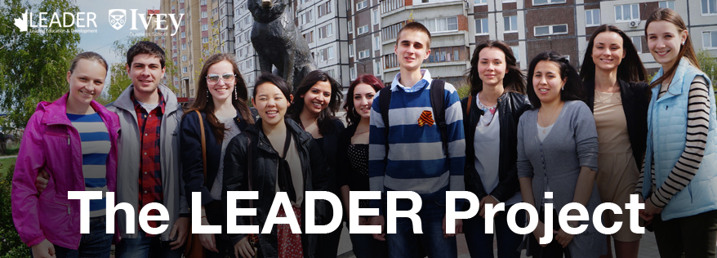

**Interactive business education for driven entrepreneurs**

The LEADER Project is a 3-week program where Canadian business students from the Ivey Business School teach you all the skills you need to know to start your own business.

|  |  |
| --- | --- |
| BOOTCAMP:Users:tsurantino:Dropbox:Ivey:ECs:LEADER M&C:LEADER Promo:imgs:learn.jpg  **LEARN THE ESSENTIAL BUSINESS SKILLS**  Study all you need to start your business: strategy, marketing, operations, and accounting | **BOOTCAMP:Users:tsurantino:Dropbox:Ivey:ECs:LEADER M&C:LEADER Promo:imgs:apply.jpg**  **APPLY YOUR KNOWLEDGE WITH CASES**  Learn by analyzing real businesses and solving their challenges by working with other students |
| **BOOTCAMP:Users:tsurantino:Dropbox:Ivey:ECs:LEADER M&C:LEADER Promo:imgs:businessplan.jpg**  **CREATE YOUR BUSINESS PLAN**  Participate in 1-on-1 coaching and create a full business plan based on best practices | **BOOTCAMP:Users:tsurantino:Dropbox:Ivey:ECs:LEADER M&C:LEADER Promo:imgs:community.jpg**  **JOIN A COMMUNITY OF ENTREPRENEURS**  Meet other entrepreneurs in your area and stay involved with the program to receive mentorship |

**Interested? Get in touch**

|  |  |
| --- | --- |
| **Class Details**  Runs from April 27 May 15,2015  Mondays & Fridays, 2-5 pm | **Contact Information tel. 230 (25-55-50)**  E-mail yekaterina803@mail.ru with your name, year, and educational background |